To connect the Tello Edu to a router, do the following:

Connect to the drone through the wifi signal it puts off by default.

* If there is no wifi signal-
  + Ensure the drone is still on
  + Hold the power button for a while to reset the drone

Using a packet sender and Wireshark, we can send DJI Tello SDK commands straight to the drone and determine the MAC address of our drone. This is useful for setting up a static IP for the drone on our network.

When connected to the drone’s network, the default IP is 192.168.10.1 and port is 8889 using the UDP protocol.

To put the drone in SDK mode, you must first send the command “command”. If the response is “ok”, you may now send other commands. Run wireshark when sending the “command” command.

Using any UDP packet from the wireshark capture, you can collect the MAC address of the drone.

Now send the command “ap ssid password”, where ssid is the name of the network you want the drone to connect to, and password is the password for that network.

Repeat for remaining drones.

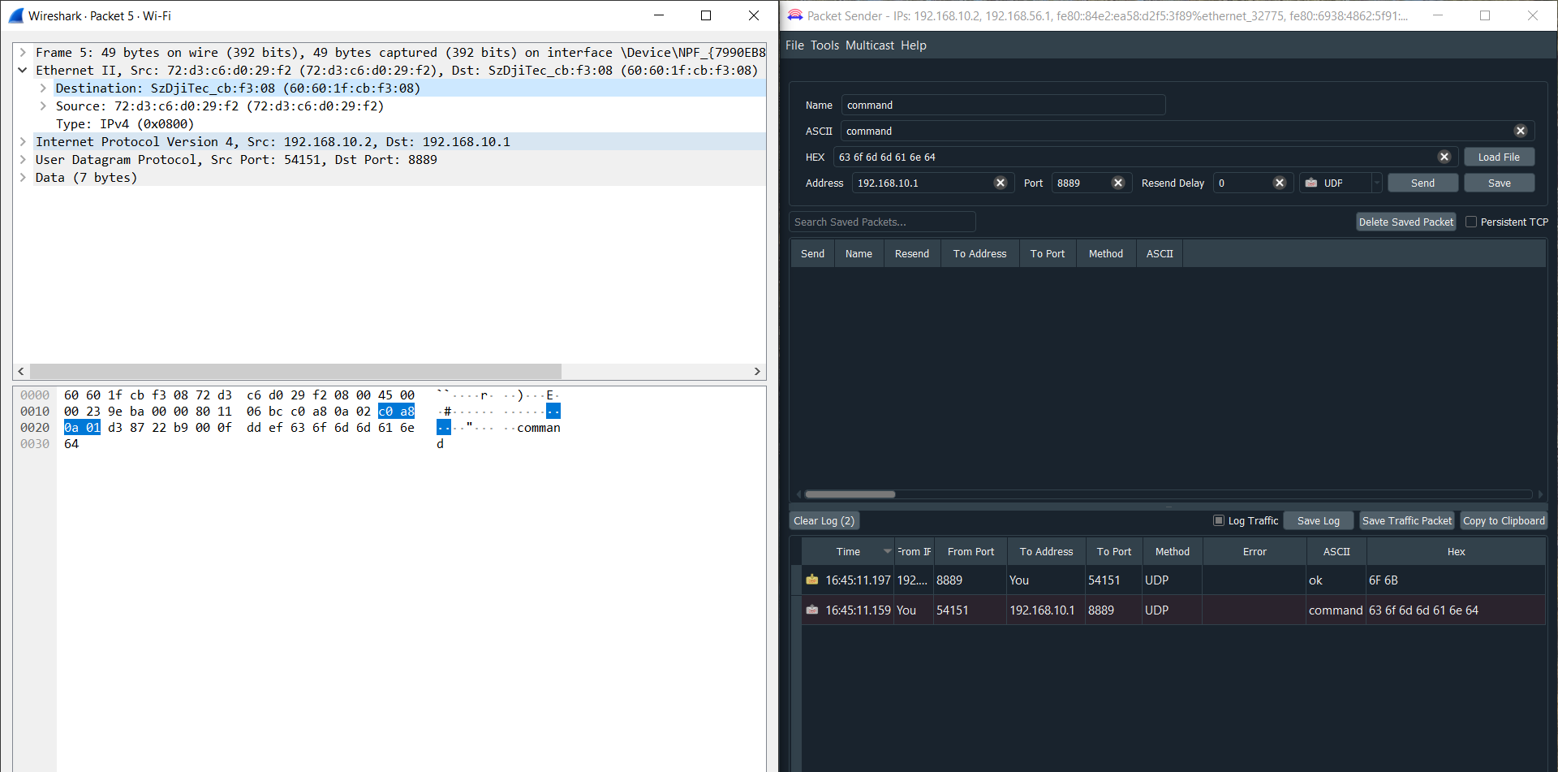

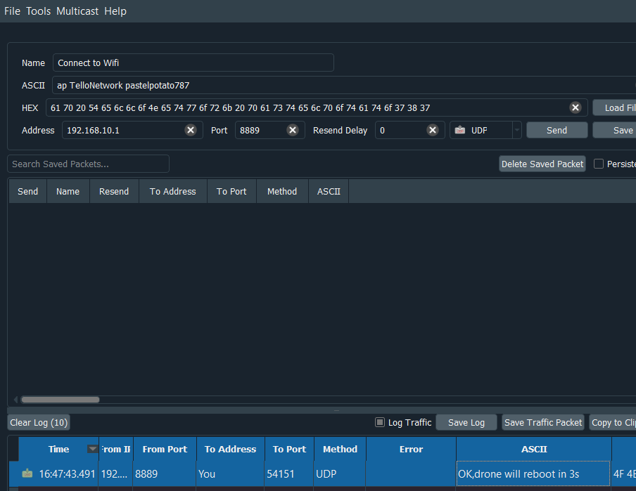

Next, you want to reserve an IP address for each drone based on it’s mac address. Do this through the LAN setup in your router.

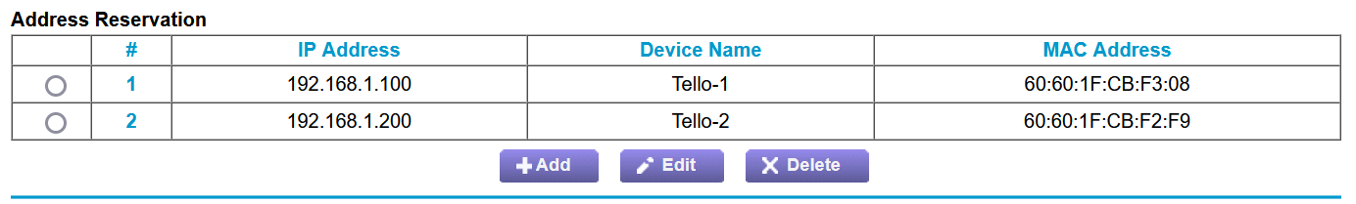After doing this, turn the drones on and ensure they are connected and given the proper IP address. If they don’t have the proper IP address, reboot them to ensure the router’s changes have had a chance to be applied.

